**DEVOPS – GIT**

GIT:

Version control system:

1. Centralized version control system. 🡪
2. Distributive version control system. 🡪

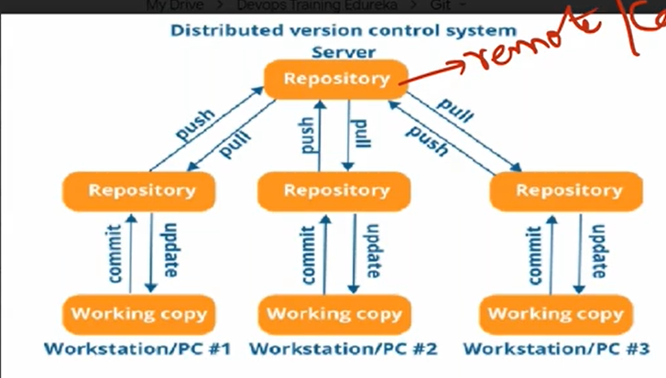

In VM or server

1. Create a local repository.
2. Copy from remote repository.
3. Empty local repository.

Commands for git:

1. Create a file 🡪 git wd
2. Add file in staging area 🡪 git add
3. Commit the code 🡪 git commit

For setting up git repository

Notes drive link

<https://drive.google.com/drive/folders/1fUgjmpN1YbmYVBCswcngpqyW9ZmDh6Sc?usp=sharing>

git init

git add README.md

git commit -m "first commit"

git branch -M main

git remote add origin https://github.com/subbaramt99/Repo_one.git

git push -u origin main

Run git bash here.

1. Git init 🡪 To initialized the repository
2. Git add index.txt 🡪 To add the index file in staging area
3. Git rm --cached index.txt 🡪index file will start tracking
4. Git status 🡪 will the status of file in stagging area
5. Git config --global user.name "subbaram"
6. Git config --global user.email "subbaramt99@gmail.com"
7. Git commit -m "index file created"
8. Git log 🡪 giving log of commits
9. Git log –oneline 🡪 the will be in single line
10. Git remote add origin <https://github.com/subbaramt99/Repo_one.git>
11. Git remote -v 🡪 it will show the origin
12. Git remote remove origin 🡪 To remove the remote origin
13. Git push -u origin master 🡪 push the file to git hub remote repo
14. Git branch Branch1 🡪 it will create the branch with name of Branch1.
15. Git add .
16. Git commit -m C3
17. Git commit -m C4
18. Git branch 🡪 will shows all the branches available
19. Git checkout Branch1 🡪 Control will move to branch1
20. Touch file 🡪 file will be create with name of ‘touch file’
21. Git checkout master 🡪 Control will move to master
22. Git commit -m “C1”
23. Git commit -m C2
24. Git merge branch1 🡪 Branch1 will merge into master
25. Git log --oneline --graph🡪It will show logs with graphical
26. Git checkout -b branch2 🡪 It will create the branch2 and enter into the branch2
27. Touch file10
28. Git add.
29. Git commit -m “C10”
30. Git checkout master
31. Touch file11
32. Git add.
33. Git commit -m “C11”
34. Git rebase branch2 🡪 Rebasing the branch2 into master
35. Git log --oneline --graph🡪 It will show logs with graphical
36. Git push -u origin branch2🡪 pushing it to branch2